**LEBANESE AMERICAN UNIVERSITY**

**USAID – HIGHER EDUCATION SCHOLARSHIP PROGRAM**

**HES - Volunteering Program Verification Form**

This form is to be used to document volunteering hours. If a student volunteers for multiple organizations, a separate form must be used for each organization. **This form must be turned in by the 28th of each month, the latest.**

I certify that the scholar Ahmad Abdallah Khalil completed a total of 5 hours of service at Life Sculptor.

The hours were completed hours as per the below:

Hours # 0 (date) _30/09 – 5/10_ (initials of supervisor) __A.K.___

Hours # 0 (date) _7/10 – 11/10_ (initials of supervisor) __A.K.___

Hours # 5 date) _14/10 – 18/10 (initials of supervisor) __A.K.___

Hours # 0 date) _21/10 -25/10 (initials of supervisor) __A.K.___

Brief description of the activities the scholar performed or participated in:

Ahmad has perfomred a bundle this month to the related topic: Social entrepreneurship applies business strategies to address social issues, benefiting local communities by creating jobs and providing essential services. These ventures face challenges like funding, balancing social and financial goals, and scaling operations. Successful initiatives like Grameen Bank showcase the impact of innovation and community engagement. Measuring social impact is key, with tools like KPIs and SROI. Future trends include more technology use and sustainable practices, while funding sources like grants and impact investing are crucial for growth. Workshop ideas can cover social entrepreneurship basics, funding, business planning, and impact measurement.

Written feedback about the scholar’s performance:

Ahmad's research on social entrepreneurship highlights his understanding of how business strategies can address social issues. His insights into challenges and future trends reflect strong analytical skills and a practical approach to creating social impact.

Please rate the overall performance of the scholar at your organization:

|  |  |  |  |
| --- | --- | --- | --- |
|  | Mastery (5) | Proficient (3) | Emerging (1) |
| **Problem solver** | X |  |  |
| **Engaged & Committed** | X |  |  |
| **Open-minded & multicultural** | X |  |  |

Signature

& stamp

__________________________

_

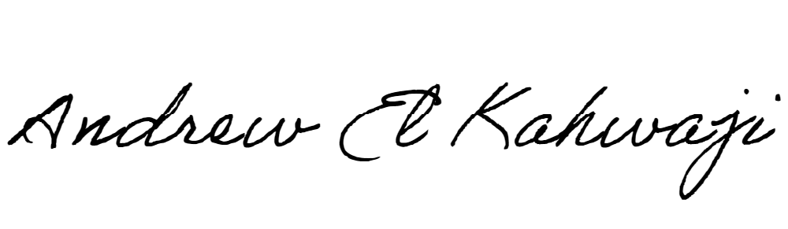

Printed Name _Andrew El Kahwaji_

Date __26/10/2024___

Email __andrew.lifesculptor.coo@gmail.com __

Phone __+961 71 914 378__

**LEBANESE AMERICAN UNIVERSITY**

**USAID – HIGHER EDUCATION SCHOLARSHIP PROGRAM**

